**ASP.NET Technology Student Activity**

Name : Sudarshan Gawale

Roll no : 176114

Year : III

Department : Computer Technology

ASP.NET Session

In ASP.NET session is a state that is used to store and retrieve values of a user.

It helps to identify requests from the same browser during a time period (session). It is used to store value for the particular time session. By default, ASP.NET session state is enabled for all ASP.NET applications.

Each created session is stored in **SessionStateItemCollection** object. We can get current session value by using **Session** property of **Page** object. Let's see an example, how to create an access session in asp.net application.

ASP.NET Session Example

In the following example, we are creating a session and storing user email. This example contains the following files.

// Default.aspx

**<**%@ Page Title="Home Page" Language="C#" AutoEventWireup="true" CodeBehind="Default.aspx.cs"

Inherits="SessionExample._Default" %**>**

**<head>**

**<style** type="text/css"**>**

        .auto-style1 {

            width: 100%;

        }

        .auto-style2 {

            width: 105px;

        }

**</style>**

**</head>**

**<form** id="form1" runat="server"**>**

**<p>**Provide Following Details**</p>**

**<table** class="auto-style1"**>**

**<tr>**

**<td** class="auto-style2"**>**Email**</td>**

**<td>**

**<asp:TextBox** ID="email" runat="server" TextMode="Email"**></asp:TextBox>**

**</td>**

**</tr>**

**<tr>**

**<td** class="auto-style2"**>**Password**</td>**

**<td>**

**<asp:TextBox** ID="password" runat="server" TextMode="Password"**></asp:TextBox>**

**</td>**

**</tr>**

**<tr>**

**<td** class="auto-style2"**>** **</td>**

**<td>**

**<asp:Button** ID="login" runat="server" Text="Login" OnClick="login_Click" **/>**

**</td>**

**</tr>**

**</table>**

**<br** **/>**

**<asp:Label** ID="Label3" runat="server"**></asp:Label>**

**<br** **/>**

**<asp:Label** ID="Label4" runat="server"**></asp:Label>**

**</form>**

* Code

// Default.aspx.cs

**using** System;

**using** System.Web.UI;

**namespace** SessionExample

{

**public** partial **class** _Default : Page

    {

**protected** **void** login_Click(**object** sender, EventArgs e)

        {

**if** (password.Text=="qwe123")

            {

                // Storing email to Session variable

                Session["email"] = email.Text;

            }

            // Checking Session variable is not empty

**if** (Session["email"] != **null**)

            {

                // Displaying stored email

                Label3.Text = "This email is stored to the session.";

                Label4.Text = Session["email"].ToString();

            }

        }

    }  }

**Output:**

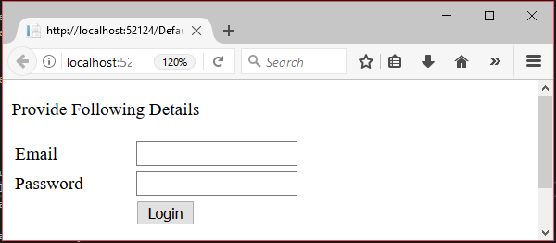

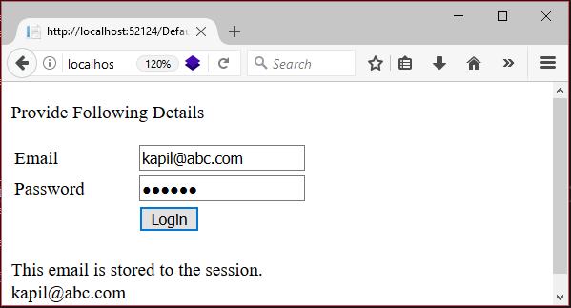

This application will store user email to the session when user login.

It will show stored session value, user email.